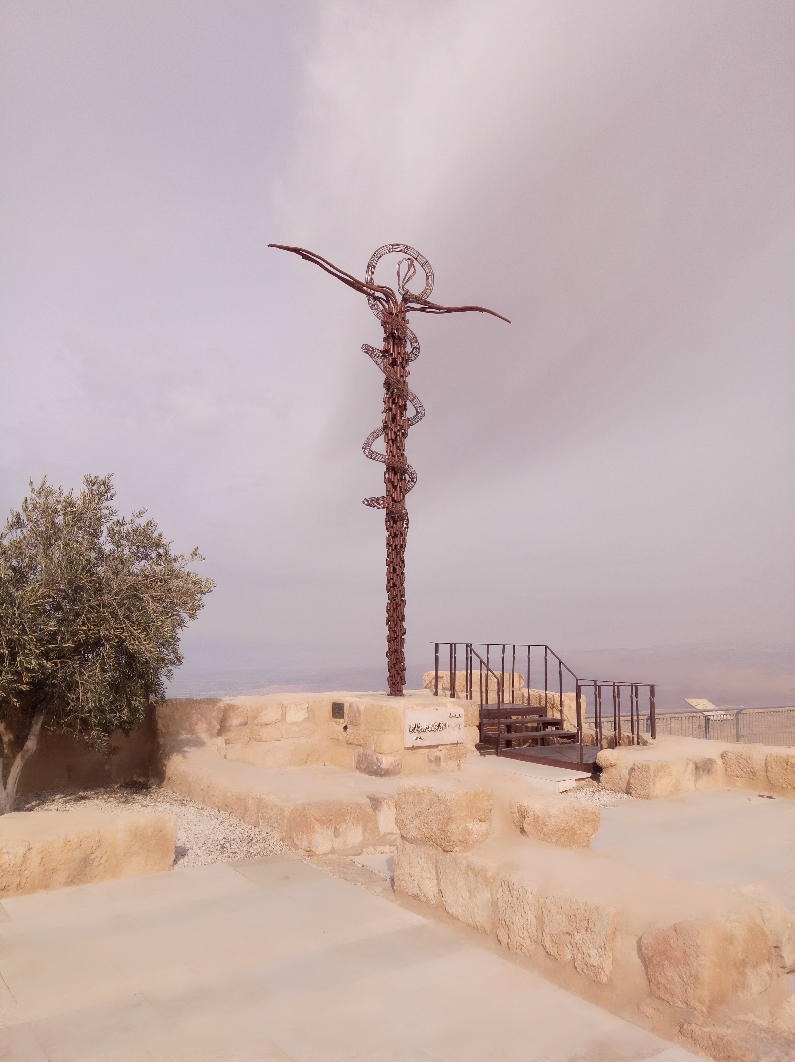

**Day 1 - Departure Perth to Dubai (EK421 22:20 - 05:20).**

**Day 2 - Arrival Dubai Connect to Amman (EK901 07:30 - 09:35), Madaba, Mt. Nebo.**

**Day 3 - Petra, Wadi Rum and Aqaba.**

**Day 4 - Aqaba, Timna, Sinai.**

**Day 5 - Mt. Sinai, St. Catherine Monastery, Negev and the Dead Sea.**

**Day 6 - The Jordan Valley and the Sea of Galilee**

**Day 7 - A Day on the Sea of Galilee and Upper Galilee**

**Day 8 - The Jezreel and the Coastal Road**

**Day 9 - O Jerusalem!**

**Day 10 - The Archaeology of Jerusalem and the New City.**

**Day 11 - Jerusalem, Old City and Transfer to Amman for Departure.**

**Day 12 - From Amman to Dubai (EK906 02:05 - 06:05); From Dubai to Perth (EK 424 09:15 - 00:05 +1 day)**

**Bookings and Cancellations**

**Bookings** can be made via our website and must be made 150 days before the departure date due to high demands. A non-refundable deposit of $200 USD is required when booking is made. The deposit is to secure accommodation bookings.

**Full payment** must be made 60 days before departure.

**All cancellations** should be in writing after the booking. The deposit will be forfeited if cancellations made 60 days before the departure date. The full tour payment will be forfeited if cancellations made within 60 days before the departure date due to the pricings applied to the group sizes. (Because heavy penalties imposed by hotels and any change of the group sizes may affect the price for the whole group and possibly the one free person for every 20 people.)



**Kairos link**

**0430 705 882**

**admin@kairoslink.com.au**

**www.kairoslink.com.au**

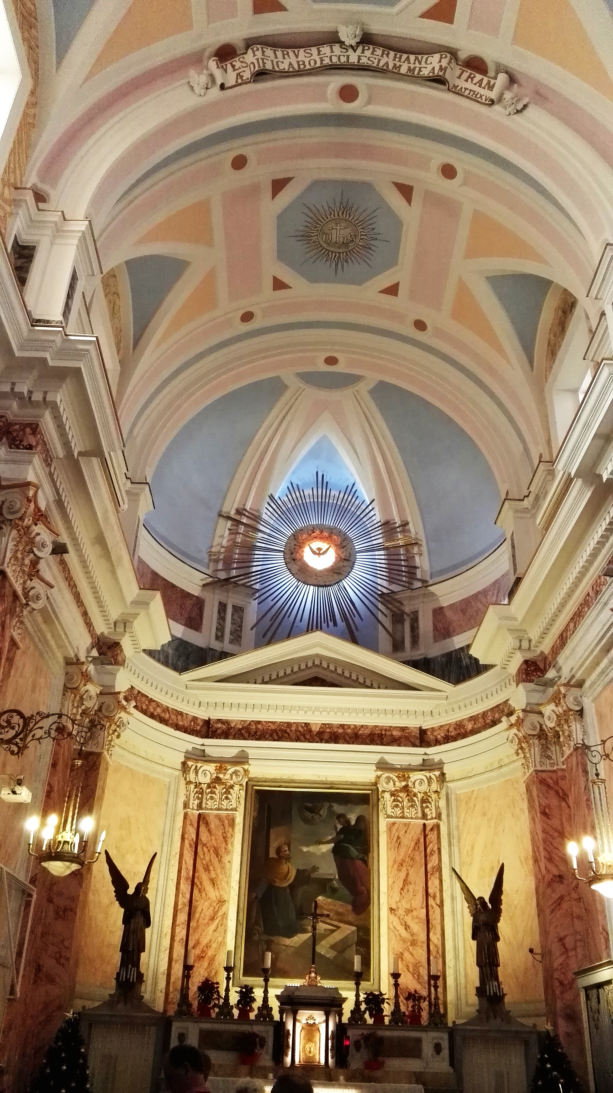

**Experience**

**The Holy Land**

**(Tour Code: PP1)**

***A 12 day program***

***brought to you by***

***KAIROS LINK***



**Please expect a 5% increase of the rates in 2020.**

* **+1 pax Free of Charge after every 20 paying pax in a twin room.**
* **+2 pax Free of Charge after every 40 paying pax in a twin room.**

If the free person is in a single room, he/she pays only the single supplement and all visa fees if applicable and border taxes. If he/she is in a double room, then he/she only pays the visa fees if applicable and the border taxes.

**The Rates Include:**

1. Hotel accommodation at the hotels or similar on HB basis (i.e. breakfast and dinner included)
2. All lunches from Day 2 to Day 11
3. Transportation by air-conditioning coach throughout the program
4. Professional English/Mandarin speaking guide
5. All entrance fees
6. Two small bottles of water daily



**International return airfare is about $1,600 AUD per person in low seasons. Price is indicative only and subject to changes.**

**The rates don’t apply to the following peak seasons:**



Roads will be closed from sunset of 09.10.2019 to sunset of 10.10.2019 except East Jerusalem**.**

