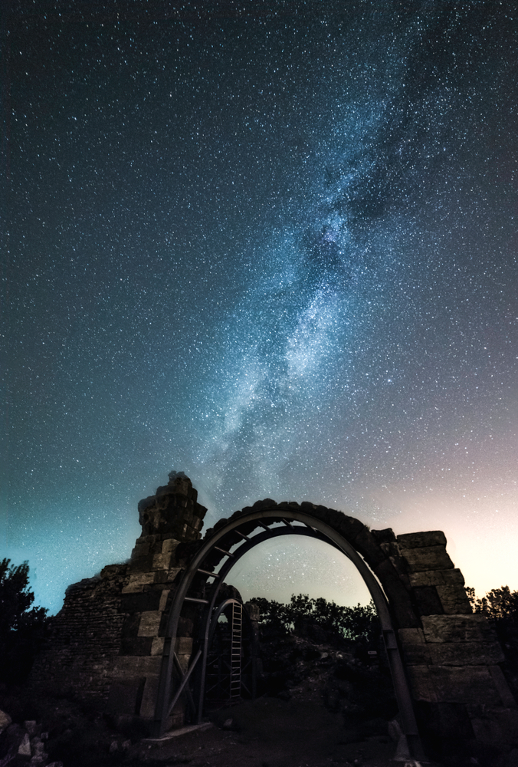

**Day 1: Leave home (QR901 22:55 – 05:40, from Perth to Doha)**

**Day 2: Istanbul – Arrival in Istanbul (QR239 07:40 – 12:25, from Doha to Istanbul)**

**Day 3: Full day in Istanbul**

**Day 4: Istanbul / Antakya / Adana**

**Day 5: Adana / Tarsus / Derbe / Konya**

**Day 6: Konya / Lystra / Antioch in Pisidia /Pamukkale**

**Day 7: Pamukkale / Hierapolis / Laodicea / Philadelphia / Sardis / Izmir**

**Day 8: Izmir / Smyrna / Ephesus / Izmir**

**Day 9: Izmir / Thyatira / Pergamum / Alexandria Troas / Canakkale**

**Day 10: Canakkale / Greek Border / Kavala**

**Day 11: Kavala / Philipi / Lydia / Thessaloniki**

**Day 12: Thessaloniki / Veria / Thessaloniki Airport / Fly to Athens**

**Day 13: Corinth**

**Day 14: Athens tour -Departure (QR204 18:05 – 23:35 From Athens to Doha)**

**Day 15: Returning home (QR900 02:30 – 18:40 from Doha to Perth)**

**Bookings and Cancellations**

**Bookings** can be made via our website and must be made 150 days before the departure date due to high demands. A non-refundable deposit of $200 USD for Turkey portion and €400 EURO for Greek portion is required when booking is made. The deposit is to secure accommodation and air flight bookings.

**Full payment** must be made 60 days before departure.

**All cancellations** should be in writing after the booking. The deposit will be forfeited if cancellations made 60 days before the departure date. The full tour payment will be forfeited if cancellations made within 60 days before the departure date due to the pricings applied to the group sizes. (Because heavy penalties imposed by hotels and any change of the group sizes may affect the price for the whole group and possibly the one free person for every 20 people.)



**Kairos link**

**0430 705 882**

**admin@kairoslink.com.au**

**www.kairoslink.com.au**

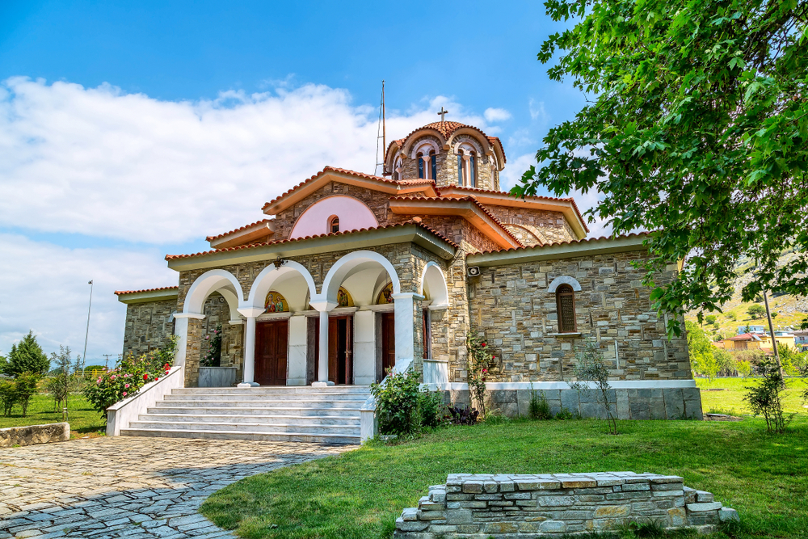

**Footsteps of**

**Saint Paul**

**(Tour Code: GS1)**

***A 15 day program***

***brought to you by***

***KAIROS LINK***

**⌛ Quotation for Turkey Portion:**



* **These rates are valid for 2019 but DO NOT apply to the Easter, Christmas and New Year peak seasons.**
* **+1 pax Free of Charge after every 20 paying pax in a twin room.**
* **+2 pax Free of Charge after every 40 paying pax in a twin room.**

**The Rates Include:**

1. Hotel accommodation at the hotels or similar on HB basis (i.e. breakfast and dinner included):
2. All lunches Day 3 to Day 9
3. Transportation by air-conditioning coach throughout the program
4. Professional English speaking guide
5. All entrance fees
6. Greek border crossing fee
7. Service charges at the hotels and restaurants in the program
8. Porterage of luggage at the hotels

**The Rates Exclude:**

1. Domestic flight from Istanbul to Antakya ($60 USD per person, subject to change before confirmation)
2. Whisper headset ($1 USD per person/day)
3. Beverages
4. Porterage of luggage at Airports.
5. Tips to the guide ($4 USD) and driver $2 USD) per person/day.
6. Visa fee ($60 USD/person) and personal expenses
7. Bottled water can be purchased on the bus ($0.50 USD per bottle)
8. International return airfare ✈

**⌛ Quotation for Greece Portion:**



* **These rates are valid for 2019 but DO NOT apply to the Easter, Christmas and New Year peak seasons.**
* **+1 pax Free of Charge after every 20 paying pax in a twin room.**
* **+2 pax Free of Charge after every 40 paying pax in a twin room.**

**The Rates Include:**

1. Hotel accommodation at the hotels or similar on HB basis (i.e. breakfast and dinner included):
2. All lunches Day 10 to Day 14
3. Deluxe bus
4. Professional English speaking guide
5. Entrance fees
6. Whisper head set
7. Residency tax

**The Rates Exclude:**

1. Domestic flight Thessaloniki – Athens (€110 EURO per person, subject to change before confirmation)
2. Beverages
3. Tips to the guide (€5 EURO), driver (€3 EURO), Housekeeping (€1 EURO), and three meals (€1 EURO x 3) per person/day
4. Visa fee and personal expenses
5. Bottled water can be purchased on the bus (€0.50 EURO per bottle)
6. International return airfare ✈

* **International return airfare is about $1,600 AUD per person in low seasons. Price is indicative only and subject to changes.**

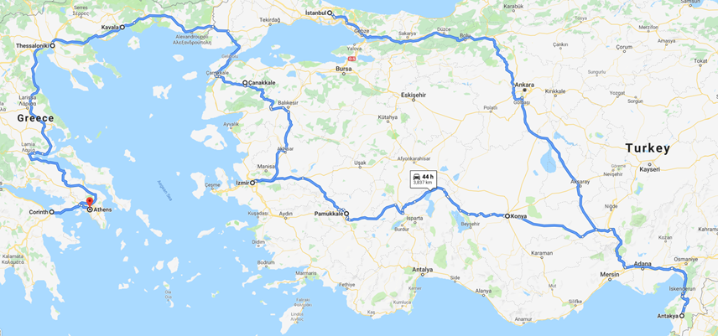

* **Please expect a 5% increase of the rates in 2020.**